John Maher

Chapter 9

Pg 327

SELECT *, first_name & ' ' & last_name AS full_name, credit_limit + 10.00 AS new_credit_limit INTO sec0902_employees FROM l_employees

| **sec0902_employees** | | | | | | | | | |
| --- | --- | --- | --- | --- | --- | --- | --- | --- | --- |
| **full_name** | **new_credit_limit** | **EMPLOYEE_ID** | **FIRST_NAME** | **LAST_NAME** | **DEPT_CODE** | **HIRE_DATE** | **CREDIT_LIMIT** | **PHONE_NUMBER** | **MANAGER_ID** |
| Susan Brown | $40.00 | 201 | Susan | Brown | Exe | 6/1/1998 | $30.00 | 3484 |  |
| Jim Kern | $35.00 | 202 | Jim | Kern | Sal | 8/16/1999 | $25.00 | 8722 | 201 |
| Martha Woods | $35.00 | 203 | Martha | Woods | Shp | 2/2/2009 | $25.00 | 7591 | 201 |
| Ellen Owens | $25.00 | 204 | Ellen | Owens | Sal | 7/1/2008 | $15.00 | 6830 | 202 |
| Henry Perkins | $35.00 | 205 | Henry | Perkins | Sal | 3/1/2006 | $25.00 | 5286 | 202 |
| Carol Rose |  | 206 | Carol | Rose | Act |  |  |  |  |
| Dan Smith | $35.00 | 207 | Dan | Smith | Shp | 12/1/2008 | $25.00 | 2259 | 203 |
| Fred Campbell | $35.00 | 208 | Fred | Campbell | Shp | 4/1/2008 | $25.00 | 1752 | 203 |
| Paula Jacobs | $25.00 | 209 | Paula | Jacobs | Mkt | 3/17/1999 | $15.00 | 3357 | 201 |
| Nancy Hoffman | $35.00 | 210 | Nancy | Hoffman | Sal | 2/16/2007 | $25.00 | 2974 | 203 |

Pg 329

SELECT employee_id, first_name, last_name, credit_limit + 10 AS 'credit_limit' FROM l_employees WHERE hire_date < #01/01/2000# ORDER BY employee_id;

| **Query1** | | | |
| --- | --- | --- | --- |
| **employee_id** | **first_name** | **last_name** | **'credit_limit'** |
| 201 | Susan | Brown | $40.00 |
| 202 | Jim | Kern | $35.00 |
| 209 | Paula | Jacobs | $25.00 |

Pg 339

SELECT n, n * 5 AS 'times 5', n / 10 AS 'over 10', 10 / n AS '10 over', iif(n <> 0, 10 / n, 'undefined') AS '10 over without 0', 2^n AS 'exponent of 2', SQR(n) AS 'square root', iif(n > 0, SQR(n), 'undefined') AS 'square root of positives', n \ 3 AS 'integer divide by 3', n mod 3 AS 'remainder of division by 3' FROM sec0908_test_numbers

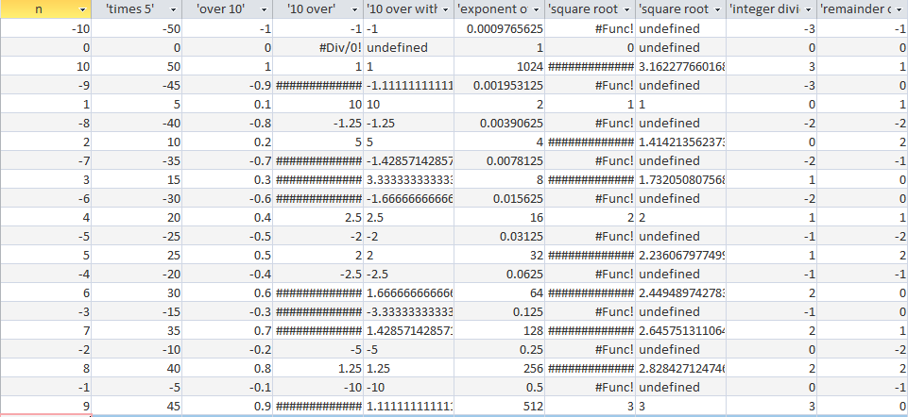

Pg 343

SELECT 'first' & 'second' AS concatenation, Mid('abcdefghij',3,4) AS 'string portion', Len('abcdefg') AS 'string length', InStr('abcdefg','cd') AS 'string search found', InStr('abcdefg','zz') AS 'string search not found', UCase('dog') AS uppercase, LCase('CAT') AS lowercase, trim(' bird ') AS trim

| **Query1** | | | | | | | |
| --- | --- | --- | --- | --- | --- | --- | --- |
| **concatenation** | **'string portion'** | **'string length'** | **'string search found'** | **'string search not found'** | **uppercase** | **lowercase** | **trim** |
| firstsecond | cdef | 7 | 3 | 0 | DOG | cat | bird |

Pg 345

SELECT EMPLOYEE_ID, Mid(LAST_NAME,1, 1) & LCase(Mid(LAST_NAME,2)) & ', ' & Mid(FIRST_NAME, 1, 1) AS Name FROM l_employees

| **Query1** | |
| --- | --- |
| **EMPLOYEE_ID** | **Name** |
| 201 | Brown, S |
| 202 | Kern, J |
| 203 | Woods, M |
| 204 | Owens, E |
| 205 | Perkins, H |
| 206 | Rose, C |
| 207 | Smith, D |
| 208 | Campbell, F |
| 209 | Jacobs, P |
| 210 | Hoffman, N |

Pg 350

SELECT Mid(Trim(phone_number), 1, 5) AS 'Area Code', Mid(Trim(phone_number), 6) AS 'Phone Number' FROM sec0912_phone_numbers

| **Query2** | |
| --- | --- |
| **'Area Code'** | **'Phone Number'** |
| (415) | 627-1445 |
| (608) | 234-5678 |
| (510) | 723-0857 |
| (362) | 942-1783 |

Pg 354

SELECT #07-mar-2011# + 2

| **Query1** |
| --- |
| **Expr1000** |
| 3/9/2011 |

SELECT #07-mar-2011# - 2

| **Query1** |
| --- |
| **Expr1000** |
| 3/5/2011 |

SELECT DateAdd('m',2,#07-mar-2011#)

| **Query1** |
| --- |
| **Expr1000** |
| 5/7/2011 |

SELECT DateAdd('yyyy',2,#07-mar-2011#)

| **Query1** |
| --- |
| **Expr1000** |
| 3/7/2013 |

SELECT #27-mar-2011# - #07-mar-2011#

| **Query1** |
| --- |
| **Expr1000** |
| 20 |

| **SEC0813_EMPLOYEES** | | | | | | | |
| --- | --- | --- | --- | --- | --- | --- | --- |
| **EMPLOYEE_ID** | **FIRST_NAME** | **LAST_NAME** | **DEPT_CODE** | **HIRE_DATE** | **CREDIT_LIMIT** | **PHONE_NUMBER** | **MANAGER_ID** |
| 201 | Susan | Brown | Exe | 6/1/1998 | $30.00 | 3484 |  |
| 202 | Jim | Kern | Sal | 8/16/1999 | $25.00 | 8722 | 201 |
| 203 | Martha | Woods | ABC | 2/2/2009 | $25.00 | 7591 | 201 |
| 204 | Ellen | Owens | Sal | 7/1/2008 | $15.00 | 6830 | 202 |
| 205 | Henry | Perkins | Sal | 3/1/2006 | $25.00 | 5286 | 202 |
| 206 | Carol | Rose | Act |  |  |  |  |
| 207 | Dan | Smith | ABC | 12/1/2008 | $25.00 | 2259 | 203 |
| 208 | Fred | Campbell | ABC | 4/1/2008 | $25.00 | 1752 | 203 |
| 209 | Paula | Jacobs | Mkt | 3/17/1999 | $15.00 | 3357 | 201 |
| 210 | Nancy | Hoffman | Sal | 2/16/2007 | $25.00 | 2974 | 203 |